|  |  |  |  |  |  |  |
| --- | --- | --- | --- | --- | --- | --- |
| **Title of Activities/Program** | **Date/ Duration** | **Documentation (Pictures)** | **Participants** | **Location** | **Conducted/ Sponsored**  **by:** | **Budget/Remark** |
| **GUIDANCE AND COUNSELING ADMISSION AND TESTING UNIT** | | | | | | |
|  |  | C:\Users\Guidance\Desktop\2nd qtr oics\279053649_5198854040174394_6587130656052062597_n.jpg  C:\Users\Guidance\Desktop\2nd qtr oics\278589975_1198592484243623_631395237048053965_n.jpg |  |  | DICT Region |  |
|  |  |  | LSPU | IV-A, GAD |  |
| Empowering LSPU-SC |  | Selected Teaching | Siniloan CCS | and | Accomplished |
| Juana and Juan | April 18-22, 2022 | and Non-Teaching | Bldg. | Faculty |  |
| Through Digital Literacy |  | employees |  | Association |  |
| Competency Training |  |  |  |  |  |

|  |  |  |  |  |  |  |
| --- | --- | --- | --- | --- | --- | --- |
| Virtual meeting for the discussion of the Guidance Research | April 20, 2022 | C:\Users\Guidance\Desktop\2nd qtr oics\april 20 meeting.png  C:\Users\Guidance\Desktop\2nd qtr oics\april 20.png | All guidance counselors andstaff | Via Gmeet | Guidance Office | Accomplished |

|  |  |  |  |  |  |  |
| --- | --- | --- | --- | --- | --- | --- |
| Virtual meeting for the discussion of the Guidance Research | April 25, 2022 | C:\Users\Guidance\Desktop\2nd qtr oics\april 25 meeting.png  C:\Users\Guidance\Desktop\2nd qtr oics\april 24.png  C:\Users\Guidance\Desktop\2nd qtr oics\april 24 meeting.png | Guidance counselors andstaff | Via Gmeet | Guidance office | Accomplished |

|  |  |  |  |  |  |  |
| --- | --- | --- | --- | --- | --- | --- |
| Virtual meeting for the discussion of the Guidance Research | April 26, 2022 | C:\Users\Guidance\Desktop\2nd qtr oics\april 26.jpg | Guidance counselors andstaff | Via Gmeet | Guidance office | Accomplished |

|  |  |  |  |  |  |  |
| --- | --- | --- | --- | --- | --- | --- |
| Virtual meeting for the online admission of Senior High School | May 2, 2022 | C:\Users\Guidance\Desktop\2nd qtr oics\may 2 with netlink.png | All guidance counselors, staff, NETLINK and ICTS | Via Gmeet | NETLINK and ICTS | Accomplished |
| Peer Facilitators followup and virtual meeting | May 6, 2022 | C:\Users\Guidance\Desktop\2nd qtr oics\may 6 meeting with peer.png | Peer FacilitatorsLSPU System, Guidance counselors and staff | Via Gmeet | Guidance Office | Accomplished |

|  |  |  |  |  |  |  |
| --- | --- | --- | --- | --- | --- | --- |
|  |  | C:\Users\Guidance\Desktop\2nd qtr oics\may 6.png |  |  |  |  |
| Start of online admissionfor SHS applicants | May 10, 2022 |  | Guidance staff | LSPU –  Siniloan online admission system | Guidance office and SHS  department | Accomplished |

|  |  |  |  |  |  |  |
| --- | --- | --- | --- | --- | --- | --- |
| GAD Gender Mainstream Seminar | May 17, 2022 | C:\Users\Guidance\Downloads\285632632_575774154055861_752915578258908153_n.jpg | LSPU SiniloanFaculty and employees | LSPU  Siniloan Gymnasium | GAD | Accomplished |
| PGCA 57th Virtual Annual National and 2022 International Conference | May 18-20, 2022 | C:\Users\Guidance\Desktop\2nd qtr oics\pgca may 18-20.png | Guidance Counselors | Via Zoom | PGCA | Accomplished |

|  |  |  |  |  |  |  |
| --- | --- | --- | --- | --- | --- | --- |
|  |  | C:\Users\Guidance\Downloads\284964024_810928546553282_5379686211524481331_n.jpg |  |  |  |  |
| Administer Exam to CHMT faculty for regularteaching position | May 19, 2022 | C:\Users\Guidance\Desktop\2nd qtr oics\may 19.jpg | Guidance staff | Testing room | Guidance office throughthe endorsemen tof HRMO | Accomplished |

|  |  |  |  |  |  |  |
| --- | --- | --- | --- | --- | --- | --- |
| Monitoring of online admission for new students of First Semester of A.Y.  2022-2023 | June 20,  2022 – July  20,  2022 |  | Guidance Staff | LSPU  Siniloan | Guidance Office | Accomplished |
| Good moral certificate request | April - June 2022 | *No pictures*  **303**  good moral certificates released | Guidance staff | LSPU-  Siniloan | Guidance office | Accomplished |
| Signing of clearance | April - June 2022 | *No pictures*  **246**  clearance signed | Guidance staff | LSPU-  Siniloan | Guidance office | Accomplished |

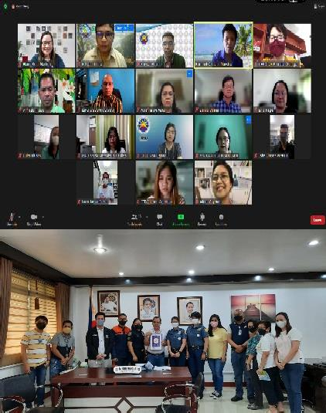

|  |  |  |  |  |  |  |
| --- | --- | --- | --- | --- | --- | --- |
| **TITLE OF ACTIVITIES/ PROGRAM** | **DATE/DURATI ON** | **DOCUMENTATION (PICTURES)** | **PARTICIPANTS** | **LOCATION** | **CONDUCTED/ SPONSORED BY** | **BUDGET/REMARKS** |
| **HEALTH AND MEDICAL UNIT** | | | | | | |
| Attended the COPC virtual visit of post baccalaureate diploma in alternative learning system program via zoom | April 4, 2022 |  | Concerned Admin Officials | Via zoom | CTE Department |  |
| Attended safety seal certification awarding ceremony | April 6, 2022 |  | LGU Inspector, DILG, MDRRMO, BFP, RHU, PNP | Board Room | CMC and UDRRM |  |

|  |  |  |  |  |  |  |
| --- | --- | --- | --- | --- | --- | --- |
| Rendered duty in case of emergency during the launch of biking that attended by the entire system and Commissioner Dr.  J. Prospero "Popoy" E. De  Vera III | April 9 and  10, 2022 |  | LSPU Officials and CHED Commissioner, LSPU President and staff | Buruwisan, Siniloan, Laguna  Caliraya, Kalayaan, Laguna | LSPU |  |

|  |  |  |  |  |  |  |
| --- | --- | --- | --- | --- | --- | --- |
| Coordinated with the OJT student with regards to the flyers and videos needed for the monthly Health Awareness Campaign. | April 13, 2022 |  | LSPU-SC  Nurse, CCS and BSAB OJT | LSPU-SC  Clinic via zoom | LSPU-SC Clinic |  |
| Attended the Digital Literacy Competency Training Participants selected faculty and non-teaching personnel | April 18, 2022 |  | Selected Teaching and Non- teaching personnel | CCS  laboratory | Computer LSPU- SC, CCS  Committee |  |

|  |  |  |  |  |  |  |
| --- | --- | --- | --- | --- | --- | --- |
| Participation in the monthly GAD activity Health and Wellness Program and disseminate monthly Health Awareness through giving of flyers and playing video presentation | April 20, 2022 |  | LSPU-SC Nurse LSPU-SC  employees | LSPU-SC  Gymnasium | GAD and Health Survivors |  |
| Dissemination information with regards to the online consultation of Dra. Reyes through LSPU-SC GC | April 2022 |  | LSPU-SC Nurse LSPU-SC  Employees | Thru Online | Health Services Unit |  |

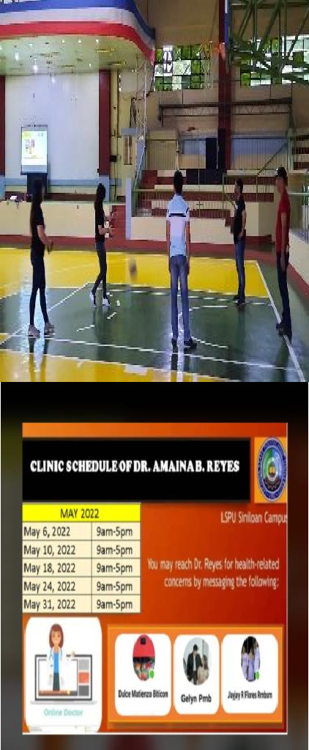

|  |  |  |  |  |  |  |
| --- | --- | --- | --- | --- | --- | --- |
| Made online referral forum time to time to Dra.  Reyes with regards to medical  concern of LSPU Students | April 2022 | **Via messenger** | LSPU-SC  Nurse, Physician, SLPU SX  Employees | Thru Online | LSPU SC Nurse |  |
| Made a report with regards to quarantined faculty and staff of LSPU.  Notified admin officials (CD, HR and Accounting) for proper  approval of Home Quarantine Employees of LSPU  Facilitated in giving medical certification and  giving home instruction of the employees who undergone quarantine | April to June 2022 | **Thru Phone** | LSPU-SC Nurse and LSPU SC Employees  LSPU-SC Nurse  LSPU SC Nurse and RHU Sanitary Officer | LSPU SC  Thru Online  Thru Online | LSPU SC Nurse  LSPU-SC Nurse  LSPU-SC Nurse |  |

|  |  |  |  |  |  |  |
| --- | --- | --- | --- | --- | --- | --- |
| Coordinated to the RHU Sanitary Officers for the Health Protocol guidelines, issuance of medical certificate schedule of RT PCR test of quarantine employees  Made Quarterly accomplishment Report and updating Quarantine  personnel reports |  |  | LSPU-SC Nurse |  | LSPU-SC Nurse |  |
| Secured schedule for an appointment of water analysis of Scientia Tech | April 15, 2022 | **Thru Phone** | LSPU-SC  Nurse, Utility, Scientia Personnel | LSPU-SC | LSPU-SC Nurse and PPSD |  |

|  |  |  |  |  |  |  |
| --- | --- | --- | --- | --- | --- | --- |
| Assisted the Scientia Tech staff in collecting water samples from different sources of water  Coordinated to the RHU Sanitary Officers and MHO of Siniloan with regards to the COVID-19 School Safety Management Seminar  Coordinated to the RHU Sanitary Officer and MHO of Siniloan with regards to the schedule of misting spray of mosquitoes inside  the school premises and ask | April 22, 2022  April 27, 2022 |  | Clinic Personnel, PPSD  Personnel and Scientia Staff  RHU Sanitary officers and MHO  RHU Sanitary officers and MHO | LSPU-SC  RHU Siniloan  RHU Siniloan  LSPU-SC  Function Hall | LSPU-SC Nurse  LSPU-SC Nurse  LSPU-SC Nurse  Crisis Management |  |

|  |  |  |  |  |  |  |
| --- | --- | --- | --- | --- | --- | --- |
| for the supply of mosquitoes’ solution and larvicide powder  Attended and participated in the COVID-19 school safety and management seminar. |  |  | RHU Personnel  , Crisis Management Personnel and , Department’s representatives |  |  |  |

|  |  |  |  |  |  |  |
| --- | --- | --- | --- | --- | --- | --- |
| Continues monitoring and ensuring that the Health Protocols were observed during the CHED TES TDP(Tertiary Education Subsidy Programs, Stipend allowances to our students grantees and dissemination of monthly health awareness through giving of flyers and playing of videos presentation |  |  | SSC Students, Student grantees, Scholarship personnel | LSPU-SC VOAG | LSPU-SC Nurse |  |

|  |  |  |  |  |  |  |
| --- | --- | --- | --- | --- | --- | --- |
| Facilitated in performing Physical Examination and assisted the medical the medical doctor in issuance of medical certificate to all OJT students | April to May 2022 |  | PPSD  Chairperson, RHU Sanitary Officer | LSPU-SC  Function Hall | LSPU-SC Nurse |  |
| Coordinated with the Sanitary Officer and PPSD chairperson with regards to the places of spraying of mosquitoes inside the campus | April 27, 2022 | **Via Messenger** | Sanitary Officer, PPSD  Chairperson | Thru phone | LSPU-SC Nurse |  |

|  |  |  |  |  |  |  |
| --- | --- | --- | --- | --- | --- | --- |
| Coordinated with the DOST with regards to the scheduling of calibrated medical equipment | April 28, 2022 |  | DOST  Personnel | DOST-LB | LSPU-SC Nurse |  |

|  |  |  |  |  |  |  |
| --- | --- | --- | --- | --- | --- | --- |
| Attended and participated on the GAD Seminar in collaboration with the medical clinic entitled” Serbisyo para kay Juan at Juana” and discussed on therapeutic use of hot and cold compress(by cluster) | May 13, 2022 |  | LSPU-SC Non-  and GAD Personnel | LSPU-SC  Canteen | LSPU-SC Nurse and GAD Chairperson |  |

|  |  |  |  |  |  |  |
| --- | --- | --- | --- | --- | --- | --- |
| Coordinated with the ICTS chairperson with regards to the dissemination of Health Awareness of Dengue Prevention | May 31, 2022 |  | ICTS  Chairperson and Clinic personnel | LSPU ICTS  Office | LSPU-SC |  |
| Intensifies information campaign with regards to the posting schedule of spraying operation inside the school premises. |  |  | Clinic personnel and OJT students | LSPU-SC | LSPU-SC Nurse |  |

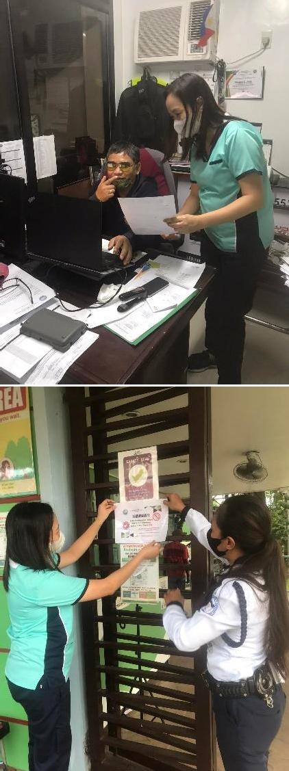

|  |  |  |  |  |  |  |  |
| --- | --- | --- | --- | --- | --- | --- | --- |
| Facilitated | June 1, 2022 |  |  | Clinic | LSPU-SC | LSPU-SC Nurse |  |
| spraying operation |  | Personnel, |  | and PPS |
| together with the |  | PPSD |  | Chairperson |
| PPSD personnel |  | Personnel and |  |  |
| with proper |  | Sanitary |  |  |
| supervision of |  | Officers |  |  |
| RHU sanitary |  |  |  |  |
| officer within the |  |  |  |  |
| school premises |  |  |  |  |
|  |  |  | |  |  |  |

|  |  |  |  |  |  |  |
| --- | --- | --- | --- | --- | --- | --- |
| Given first aid treatment to One of the LSPU employees with high blood pressure and refused to transfer to the nearest hospital for proper evaluation and management | June 3, 2022 | C:\Users\PC24\Downloads\287358965_1633474297031952_261479262474596173_n.jpg | Clinic Personnel | LSPU-SC  Clinic | LSPU-SC Nurse |  |
| Facilitated orientation with the OJT students assignment at the clinic for voluntary |  | C:\Users\PC24\Desktop\286274153_511841347389736_4794902704261037924_n.jpg | OJT students | LSPU-SC | LSPU-SC Nurse |  |

|  |  |  |  |  |  |  |
| --- | --- | --- | --- | --- | --- | --- |
| Attended Crisis Management Committee via zoom meeting with regards to the updates on the status of the conduct of limited face to face  classes |  | C:\Users\PC24\Desktop\287555544_485359903350042_8410684622819536458_n.jpg | LSPU-SC Crisis Management Committee, LSPU-SC Nurse | Thru zoom |  |  |
| Facilitated inspection rounds with regards to the prepared for the Isolation Area |  | C:\Users\PC24\Desktop\286176570_435745151332473_534322233299411922_n.jpg  C:\Users\PC24\Desktop\286020938_750783256115974_7674383330287553014_n.jpg | Clinic Personnel, Supply Chairperson, PPSD  Personnel | LSPU-SC | LSPU-SC Nurse |  |

|  |  |  |  |  |  |  |
| --- | --- | --- | --- | --- | --- | --- |
| Intensified information campaign with regards to the monthly health awareness through giving of flyers and posting in the LSPU-SC group chat | June 9, 2022 | C:\Users\PC24\Desktop\287526393_700919217637598_1685598482472531501_n.jpg  C:\Users\PC24\Desktop\287032322_454439356406518_7496818296819499506_n.jpg | OJT Students and LSPU-SC Departments | LSPU-SC | LSPU-SC Nurse |  |
| Participated in the national simultaneous earthquake drill at LSPU –SC  Campus | June 9, 2022 | C:\Users\PC24\Desktop\287907176_645182306785527_2841693254597287216_n.jpg | LSPU-SC  Employees | LSPU-SC | LSPU DRRMO(Marc Sylvester Garcia) and PPSD Chairperson( Wilfredo G. Tuso III) |  |

|  |  |  |  |  |  |  |
| --- | --- | --- | --- | --- | --- | --- |
| Coordinated with the RHU coordinator for Mental Health and Smoking Awareness by helping them to disseminate their awareness campaign thru social medical platform(messeng  er group chats) | June 10, 2022 | C:\Users\PC24\Desktop\285885665_1184447389005636_4162762522898381538_n.jpg | RHU and Clinic Personnel | LSPU-SC  Clinic | LSPU-SC Nurse |  |
| Participated and coordinated to different colleges of LSPU with regards to the necessary documents needed by the accreditors from clinic. | June 13-16,  2022 | C:\Users\PC24\Desktop\289831731_5714006695385349_8348970666246499898_n.jpg | Clinic Personnel | LSPU-SC  Clinic | LSPU-SC Nurse |  |
| Attended and participated in the LSPU Siniloan Campus Virtual  Tour | June 14, 2022 | Thru Phone |  | Thru Phone |  |  |

|  |  |  |  |  |  |  |
| --- | --- | --- | --- | --- | --- | --- |
| Coordinated with the Red Cross Coordinator for the plans of bloodletting activity. |  | C:\Users\PC24\Desktop\289155602_395344962555300_3933344841241262135_n.jpg | Red Cross and Clinic Personnel | LSPU-SC  Clinic | LSPU-SC Nurse |  |
| Coordinated with the RHU Siniloan and made announcement through group chat for faculty and students for the schedule of COVID-19  vaccination. | June 15, 2022 | C:\Users\PC24\Downloads\288972531_581856230225426_681684634525703481_n.jpg | RHU and Clinic Personnel | LSPU-SC  Clinic | LSPU-SC Nurse |  |

|  |  |  |  |  |  |  |
| --- | --- | --- | --- | --- | --- | --- |
| Coordinated with the UDRRM Chairperson and SSC officers and set a pear for the needed to be prepared during bloodletting activity. | June 15, 2022 |  | SSC and UDRRM  Chairperson | LSPU-SC  Clinic | LSPU-SC Nurse |  |
| Attended Admin Council meeting at LSPU-SC Board Room | June 20, 2022 |  | Admin Council | LSPU-SC  Clinic | CD Sancon |  |

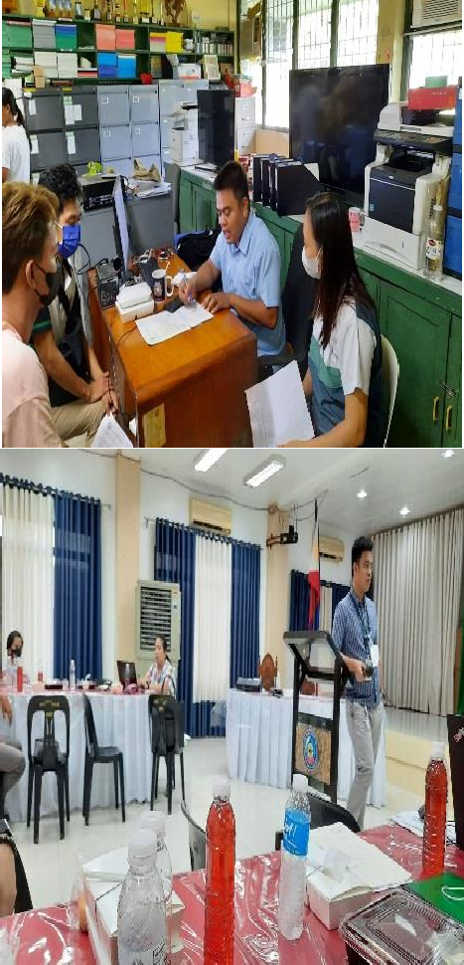

|  |  |  |  |  |  |  |
| --- | --- | --- | --- | --- | --- | --- |
| Attended COPC Virtual Visit of Bachelor of Science in Food Tech (BSFT) Program. | June 21, 2022 |  | LSPU-SC Clinic and other units | Thru Zoom | BSFT Department |  |
| Meeting with the SSC officer's and set a plan for the upcoming Blood donation. | June 22, 2022 |  | SSC | LSPU-SC  Clinic | LSPU-SC Nurse |  |

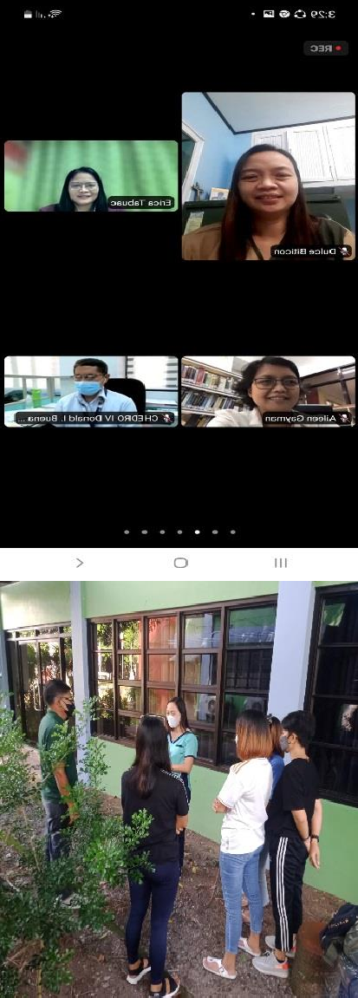

|  |  |  |  |  |  |  |
| --- | --- | --- | --- | --- | --- | --- |
| Facilitated the Blood Letting Activity together with the Red Cross personnel in coordination with the UDRRM and SSC student officers. | June 22, 2022 | C:\Users\PC24\Downloads\290084278_446008374037749_7683235315427280833_n.jpg  C:\Users\PC24\Downloads\290022096_701486884474198_13415450316069937_n.jpg | LSPU-SC  Employees, outsider blood donors, UDRRM Chairperson and SSC | LSPU-SC  Clinic | LSPU-SC Nurse |  |
| Coordinated with the RHU,Siniloan with regards to the suspected Covid 19 case of LSPU,SC. | June 27, 2022 | **Thru Phone** | RHU Disease Surveillance Officer and Clinic personnel | Thru Phone | LSPU-SC Nurse |  |

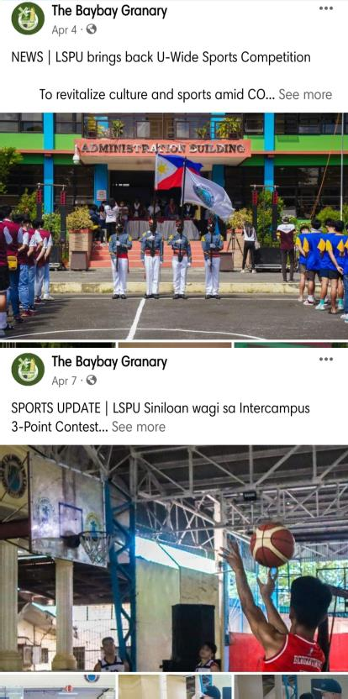

|  |  |  |  |  |  |  |
| --- | --- | --- | --- | --- | --- | --- |
| **TITLE OF ACTIVITIES/ PROGRAM** | **DATE/DURATI ON** | **DOCUMENTATION (PICTURES)** | **PARTICIPANTS** | **LOCATION** | **CONDUCTED/ SPONSORED BY** | **BUDGET/REMARKS** |
| **STUDENT PUBLICATION UNIT** | | | | | | |
| Coverage of LSPU U- wide Sports Competition | April 4, 2022 |  | LSPU students | LSPU Sta. Cruz | LSPU | Accomplished |
| Coverage of Three Point Shooting Contest during the LSPU U-wide Sports Competition | April 6, 2022 |  | LSPU Basketball Athletes | LSPU Sta. Cruz | LSPU | Accomplished |

|  |  |  |  |  |  |  |
| --- | --- | --- | --- | --- | --- | --- |
| Coverage of futsal girls during the LSPU U-wide Sports Competition | April 6, 2022 |  | LSPU Futsal athletes | LSPU Sta. Cruz | LSPU | Accomplished |
| Coverage of finals basketball girls during the LSPU U-wide Sports Competition | April 6, 2022 |  | LSPU Siniloan and Sta. Cruz Basketball Girls | LSPU Sta. Cruz | LSPU | Accomplished |

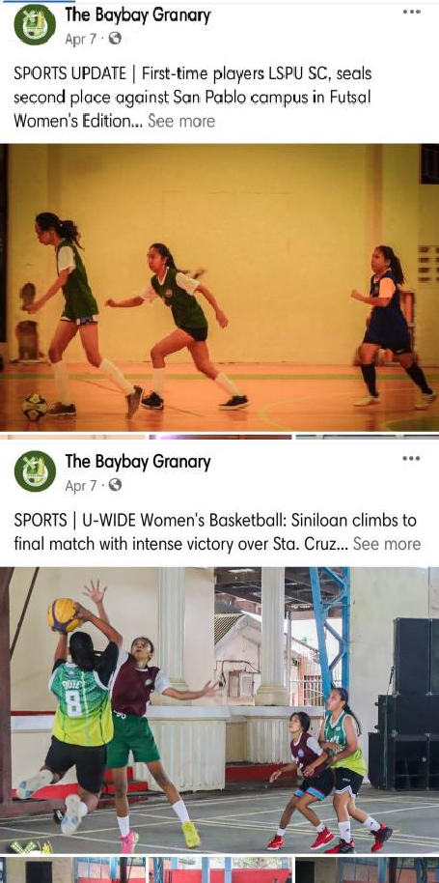

|  |  |  |  |  |  |  |
| --- | --- | --- | --- | --- | --- | --- |
| Coverage of the Closing Ceremony and Awarding during the LSPU U-wide Sports Competition | April 6, 2022 |  | LSPU athletes, staffs and coaches | LSPU Sta. Cruz | LSPU | Accomplished |
| Coverage of First Regular Board of Regents Meeting | April 8, 2022 |  | LSPU Board of Regents | LSPU Siniloan | LSPU Siniloan | Accomplished |

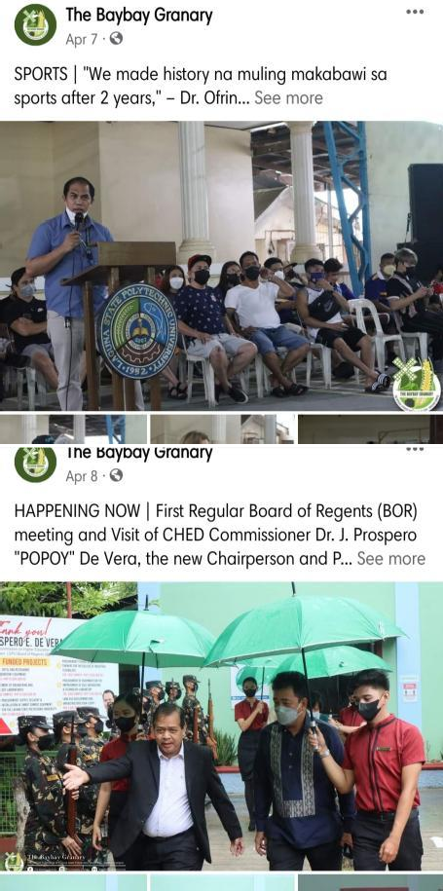

|  |  |  |  |  |  |  |
| --- | --- | --- | --- | --- | --- | --- |
| Coverage of LPSU Siniloan Academic Building Inauguration | April 8, 2022 |  | LSPU Board of Regents | LSPU Siniloan | LSPU Siniloan | Accomplished |
| . News Article of LSPU SC Webinar Series: Linguistics, Language Teaching and Literature | April 8, 2022 |  | LSPU SC students | Zoom Meeting | College of Teacher Education | Accomplished |

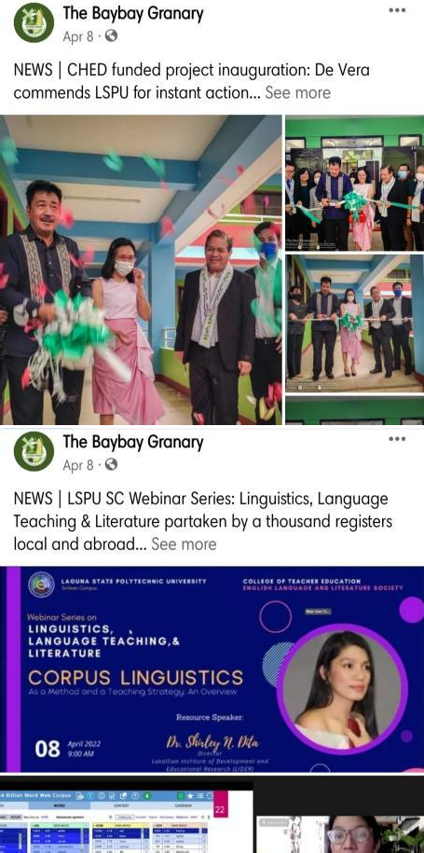

|  |  |  |  |  |  |  |
| --- | --- | --- | --- | --- | --- | --- |
| Coverage of LSPU Cycling Club Launching | April 9, 2022 | Screenshot_20220704-100343_Facebook | LSPU Board of Regents | LSPU Siniloan | LSPU Siniloan | Accomplished |
| Feature Article of New Academic Building | April 13, 2022 | Screenshot_20220704-100350_Facebook | The Baybay Granary staff writer | The Baybay Granary Facebook page | The Baybay Granary | Accomplished |

|  |  |  |  |  |  |  |
| --- | --- | --- | --- | --- | --- | --- |
| Coverage of U-wide Health Insurance Orientation | April 13, 2022 |  | LSPU faculty, students and PhilHealth Personnel | Zoom Meeting | LSPU | Accomplished |
| Literary Article for April | April 17, 2022 |  | The Baybay Granary Editor-in- Chief | The Baybay Granary Facebook page | The Baybay Granary | Accomplished |

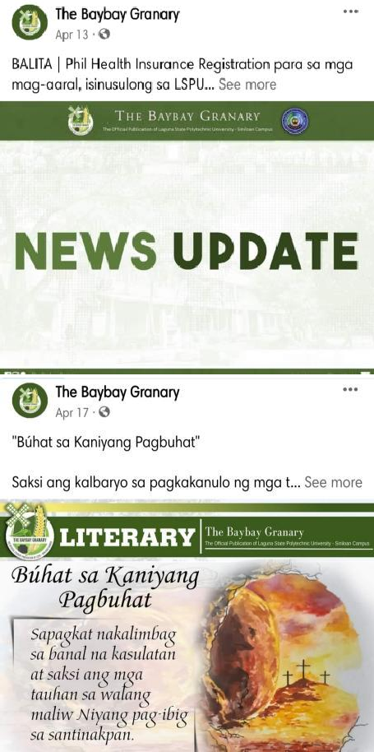

|  |  |  |  |  |  |  |
| --- | --- | --- | --- | --- | --- | --- |
| Feature Article of Newly Elected PSABE- PPG National President | May 10, 2022 |  | The Baybay Granary Associate Editor and Editor- in-Chief | The Baybay Granary Facebook page | The Baybay Granary | Accomplished |
| News Article of OFAD Society Webinar Series | May 16, 2022 |  | BS Office Administration Students | Zoom Meeting | Office Administration Society | Accomplished |

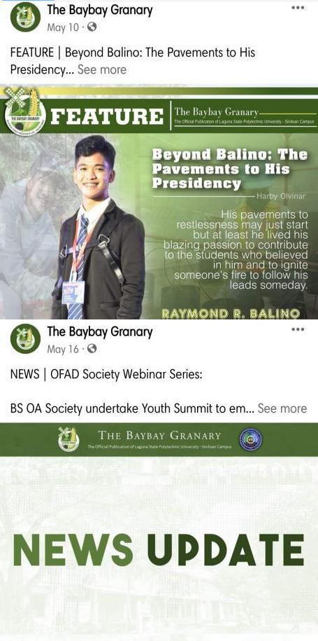

|  |  |  |  |  |  |  |
| --- | --- | --- | --- | --- | --- | --- |
| Day 1 of The Baybay Granary In-House Workshop | June 17, 2022 |  | The Baybay Granary members and LSPU SC Students | LSPU Siniloan Function Hall and Library | The Baybay Granary | Accomplished |
| Day 2 of The Baybay Granary In-House Workshop | June 18, 2022 |  | The Baybay Granary members and LSPU SC Students | LSPU Siniloan Function Hall and Library | The Baybay Granary | Accomplished |

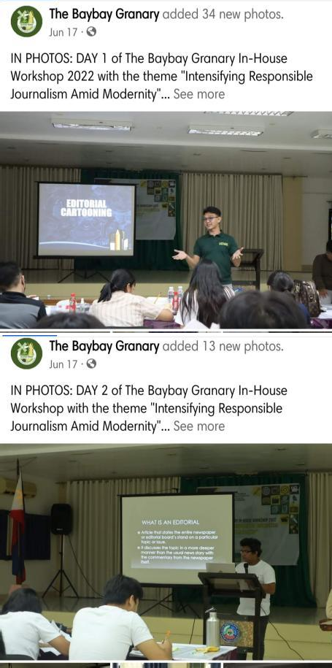

|  |  |  |  |  |  |  |
| --- | --- | --- | --- | --- | --- | --- |
| Day 2 and Awarding Ceremony of The Baybay Granary In- House Workshop | June 18, 2022 |  | The Baybay Granary members and LSPU SC Students | LSPU Siniloan Function Hall and Library | The Baybay Granary | Accomplished |
| Coverage of LSPU SC Blood Letting Activity | June 23, 2022 |  | LSPU Siniloan students, faculty and staffs | LSPU Siniloan Function Hall | University Clinic | Accomplished |

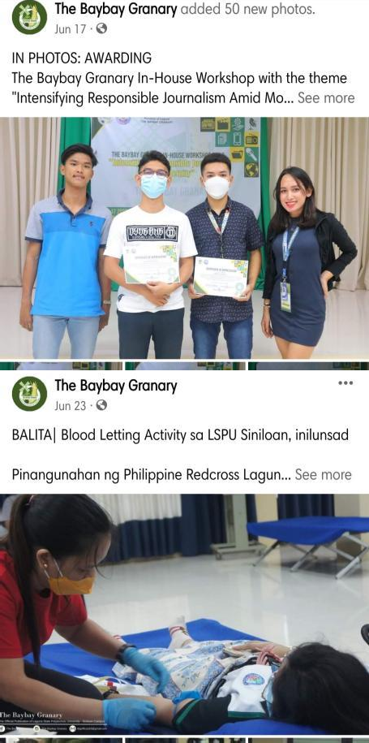

|  |  |  |  |  |  |  |
| --- | --- | --- | --- | --- | --- | --- |
| Coverage of Gender and Development Seminar | June 24, 2022 |  | LSPU Siniloan student leaders | LSPU Siniloan Function Hall | Gender and Development Office | Accomplished |
| Coverage of College of Business Administration and Accountancy Week 2022 Quiz Bee | June 28, 2022 |  | CBAA students | University Gymnasium | College of Business Administration and Accountancy SBO and Supreme Student Council | Accomplished |

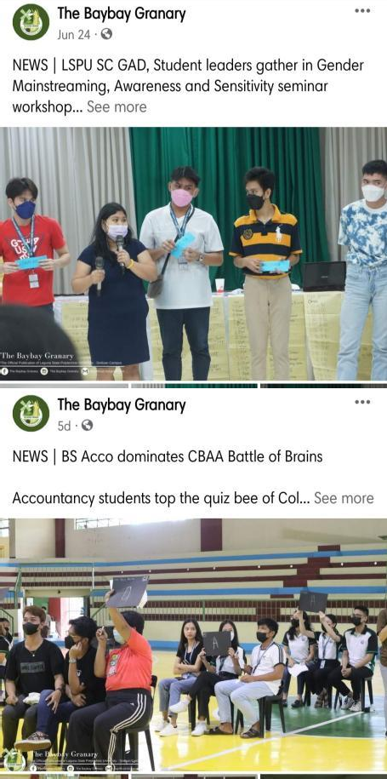

|  |  |  |  |  |  |  |
| --- | --- | --- | --- | --- | --- | --- |
| Coverage of College of Business Administration and Accountancy Week Day 2 and 3 | June 29-30,  2022 | Screenshot_20220704-100511_Facebook | CBAA students | University Gymnasium | College of Business Administration and Accountancy SBO and Supreme Student Council | Accomplished |

|  |  |  |  |  |  |  |
| --- | --- | --- | --- | --- | --- | --- |
| **TITLE OF ACTIVITIES/ PROGRAM** | **DATE/DURATION** | **DOCUMENTATION (PICTURES)** | **PARTICIPANTS** | **LOCATION** | **CONDUCTED/ SPONSORED BY** | **BUDGET/REMARKS** |
| **ALUMNI AFFAIRS AND PLACEMENT SERVICES UNIT** | | | | | | |
| Coordination Meeting with AAPS College Coordinators | May 19, 2022 |  | A/Prof. Rogacion U. Villanueva, AAPS Chairperson and AAPS Coordinators | Google Meet | A/Prof. Rogacion U. Villanueva, AAPS Chairperson | Accomplished |
| Jobs180.com Marketing Me at LSPU | May 27, 2022 |  | LSPU System Graduating Students | Zoom, Facebook and YouTube Platforms | Jobs180.com and LSPU | Accomplished |

|  |  |  |  |  |  |  |
| --- | --- | --- | --- | --- | --- | --- |
| **TITLE OF ACTIVITIES/ PROGRAM** | **DATE/DURATION** | **DOCUMENTATION (PICTURES)** | **PARTICIPANTS** | **LOCATION** | **CONDUCTED/ SPONSORED BY** | **BUDGET/REMARKS** |
| **SUPREME STUDENT COUNCIL** | | | | | | |
| Participated in NSPT CWTS Lecture Video: Emergency Response and Transfer | April 08, 2022 |  | NSTP Coordinators and Supreme Student Council | LSPU Siniloan | NSTP Coordinators | Accomplished |
|  |  |  | SSC Officers and |  |  |  |
| Attended SSC  Consultative Meeting | April 14, 2022 | Student Body  Organization | Via Zoom Meeting | SSC and SBO | Accomplished |
| with Student Body |  |  |  |  |  |
| Organizations and |  |  |  |  |  |
| Societies |  |  |  |  |  |

|  |  |  |  |  |  |  |
| --- | --- | --- | --- | --- | --- | --- |
| Attended the Meeting about Smart Gen | April 24, 2022 |  | FSSC Officer | Via Google Meet | FSSC | Accomplished |
| Hosted the LSPU SC BSBA consultation meeting on limited Face to Face Classes | April 27, 2022 |  | BSBA Students, Parents and Faculty | Via Zoom Meeting | College of Business Administration and Accountancy | Accomplished |
| Attended the meeting with the COE Department Student Body Organization | April 27, 2022 |  | SSC and COE Officers | Via Google Meet | COE Department | Accomplished |

|  |  |  |  |  |  |  |
| --- | --- | --- | --- | --- | --- | --- |
| Signed Memorandum of Agreement between LSPU Siniloan SSC and Sandiwa Philippines | April 28,2022 |  | LSPU Siniloan SSC and Sandiwa Philippines |  | LSPU Siniloan SSC and Sandiwa Philippines | Accomplished |
| Conducted the Pinas Elect: A Voters’ E- leksyon Webinar in partnership with Sandiwa PH | April 30, 2022 |  | LSPU SC Students and Sandiwa PH | Via Zoom Conference and Facebook Live | Supreme Student Council and Sandiwa PH | Accomplished |
| conducted the second day of Pinas Elect: A Voters’ E- leksyon Webinar In partnership with Sandiwa PH. | May 06, 2022 |  | LSPU SC Students and Sandiwa PH | Via Zoom Conference and Facebook Live | Supreme Student Council and Sandiwa PH | Accomplished |

|  |  |  |  |  |  |  |
| --- | --- | --- | --- | --- | --- | --- |
| Attended the OFAD Society Webinar | May 14, 2022 |  | Supreme Student Council and OFAD Society | Via Zoom Conference | OFAD Society | Accomplished |
| Conducted a Two- day Local Leadership Training | May 19-20, 2022 |  | SSC and Student Organizations and Societies of LSPU Siniloan with Satellite Campus | Via Zoom Conference and Facebook Live | Supreme Student Council | Accomplished |

|  |  |  |  |  |  |  |
| --- | --- | --- | --- | --- | --- | --- |
| Attended the CBAA Student Body Organization Consultative Meeting | June 12, 2022 |  | SSC and SBO Officers | Via Google Meet | CBAA Student Body Organization | Accomplished |
| Accomplished the SSC regular Meeting | June 14, 2022 |  | SSC Officers | Via Google Meet | Supreme Student Council | Accomplished |
| Meeting with the DRRM and University Nurse for the Blood Letting Activity | June 15, 2022 |  | SSC President, University Nurse and DRRM Head | LSPU Siniloan | DRRM | Accomplished |

|  |  |  |  |  |  |  |
| --- | --- | --- | --- | --- | --- | --- |
| Participated in the BAYBAY Granary's workshop | June 16-17, 2022 |  | LSPU Students | LSPU Siniloan | LSPU Siniloan Baybay Granary | Accomplished |
| Conducted a Blood Letting Activity | June 23, 2022 |  | Red Cross, LSPU Students, Faculty and community. | LSPU Siniloan | DRRM, University Clinic and Supreme Student Council | Accomplished |

|  |  |  |  |  |  |  |
| --- | --- | --- | --- | --- | --- | --- |
| Attended a seminar workshop on Creating a Shared Vision and Sensitivity among Student Leaders for Future Projects, Programs, Activities (PPAs), Policies and Regulations | June 24, 2022 |  | SSC, SBO and Society of LSPU Siniloan Campus | LSPU Siniloan | Supreme Student Council and Gender and Development Unit | Accomplished |

|  |  |  |  |  |  |  |
| --- | --- | --- | --- | --- | --- | --- |
| Host in the Employability skills training program of CBAA | June 27, 2022 |  | CBAA 4th year students | LSPU Siniloan | BSBA Coordinator | Accomplished |
| Co-hosted the CBAA Week in LSPU Siniloan | June 28-30, 2022 |  | CBAA Students | LSPU Gymnasium, | CBAA Student Body Organization and Supreme Student Council | Accomplished |

|  |  |  |  |  |  |  |
| --- | --- | --- | --- | --- | --- | --- |
| **TITLE OF ACTIVITIES/**  **PROGRAM** | **DATE/DURATION** | **DOCUMENTATION (PICTURES)** | **PARTICIPANTS** | **LOCATION** | **CONDUCTED/ SPONSORED BY** | **BUDGET/REMARKS** |
| **SCHOLARSHIP AND FINANCIAL ASSISTANCE UNIT** | | | | | | |
| SFA Meeting | April 12,2022 |  | San Pablo Campus, Sta. Cruz Campus, Los Banos Campus, and Siniloan Campus | Via Google Meet | Siniloan SFA Office | **Accomplished** |
| Zoom meeting Topic: University- Wide Health Insurance Orientation | April 13,2022 |  | Students and Faculty Members | Via Zoom | OSAS Office and PHILHEALTH-Field  Staff | **Accomplished** |
| Released of TES- TDP Stipend Allowance for Second Semester 2021-2022 | April 18, 19, 20, 21  and 22, 2022 |  | SFA Director, Staff and Student | LSPU Siniloan- VOAG | SFA Office | **Accomplished** |

|  |  |  |  |  |  |  |
| --- | --- | --- | --- | --- | --- | --- |
| Monitoring, Evaluation and Validation of DA- ACEF Scholarship | April 20, 2022 |  | DA ACEF staff, SFA Director and Chairperson/LB Campus  SFA/LB Campus SFA/Siniloan Campus | LSPU Siniloan Campus Board room | DA ACEF staff/ SFA Office | **Accomplished** |
| Submission of Liquidation Report of Angkla, TES- TDP/TES and ANNEX 5 form 1-4 of TES-TDP and TES to CHED Lipa, Batangas | May 13, 2022 |  | San Pablo Campus, Sta. Cruz Campus, Los Banos Campus, and Siniloan Campus | CHED IV-A-Lipa  Batanags | CHED IV-A-Lipa  Batanags Staff | **Accomplished** |
| Zoom Meeting Credentials for Monthly Coordination Meeting 8am-1pm | May 27, 2022 |  | SFA Directors, Chairpersons, Technical Staff and CHED staff | Via Zoom | UniFast Unit of CHED Regional Office IV-A | **Accomplished** |

|  |  |  |  |  |  |  |
| --- | --- | --- | --- | --- | --- | --- |
| Admin Council Meeting | June 20, 2022 |  | Admin Council Members | LSPU Siniloan | Admin Council members | **Accomplished** |
| CHED Face-to-Face coordination Meeting | June 27, 2022 |  | SFA Directors, Chairpersons, Technical Staff and CHED staff | CHED IV-A-Lipa  Batanags | UniFast Unit of CHED Regional Office IV-A | **Accomplished** |

|  |  |  |  |  |  |  |
| --- | --- | --- | --- | --- | --- | --- |
| **TITLE OF ACTIVITIES/ PROGRAM** | **DATE/DURATIO N** | **DOCUMENTATION**  **(PICTURES)** | **PARTICIPANT S** | **LOCATION** | **CONDUCTED/ SPONSORED BY** | **BUDGET/REMARK S** |
| **STUDENT ORGANIZATIONS AND ACTIVITIES** | | | | | | |
| Academic  Excellence Recognition  Ceremony | April 4, 2022 |  | LSPU SC  Engineering Students’ Guild,  COE  Students, COE Faculty, | via ZOOM | LSPU SC  Engineering Students’ Guild | Php 0.00 |
| Halika, Usap Tayo - A virtual Kamustahan | April 6, 2022 |  | All criminology students (1st year to 4th year) | Virtual | College of Criminal Justice Education SBO | Accomplished |
| Webinar Series On Linguistics, Language Teaching and  Literature | April 08, 2022  April 15, 2022  April 22, 2022  April 29,  2022  May 06, 2022 |  | English majors,  Students, Professors From The English Department And Students&  Teachers From | Via Zoom And Fb Live | College Of Teacher Education And English Language And  Literature Society | Php 25, 000/ Accomplished |

|  |  |  |  |  |  |  |  |
| --- | --- | --- | --- | --- | --- | --- | --- |
|  |  |  | Different School And Universities |  |  |  | |
| Tree Planting: “BAYAWNIHAN  -Puno ko Para sa Kalikasan” | April 23,2022/ 8AM-12PM |  | PSABE-PPG LSPU  Chapter Officers Faculty Members and  Staff | LSPU Land Grant Kapatalan, Siniloan Laguna Brgy.  Galalan, Pangil, Laguna | Conducted by PSABE-PPG, PG  National, LSPU Chapter Sponsored by PSABE-PG  Region  4A Chapter and PSABE-PPG  LSPU Chapter | Php 3,000.00  Accomplished |  |
| Tulong Acads | April 23 – July 2, 2022 |  | LSPU SC  Engineering Students’ Guild, BSABE 1st  and 2nd year, BSME 1st  and 2nd year, | via Google Meet | LSPU SC  Engineering Students’ Guild | Php 0.00 |

|  |  |  |  |  |  |  |
| --- | --- | --- | --- | --- | --- | --- |
|  |  |  | BSCpE 1st and 2nd year |  |  |  |
| PSABE Annual National Convention  18th International Agricultural Engineering Conference  33rd Philippine Agricultural Engineering Week,  8th ASEAN  Agricultural Engineering Annual Regional Convention 2022 (ARC  2022) | April 25-27  2022 |  | PSABE-PPG LSPU  Chapter Officers, Students, Teachers, Faculties, and  Staff of the DABE | Virtual/ Cagayan De Oro | Conducted by PSABE-PPG  and  PG NATIONAL  Sponsored by LSPU, PSABE- PPG  LSPU CHAPTER, and PSABE-PG  Region 4A Chapter | Php 30,000.00  Accomplished |

|  |  |  |  |  |  |  |
| --- | --- | --- | --- | --- | --- | --- |
|  |  |  |  |  |  |  |
| Annual Reading Of Nick  Joaquin`S “May Day Eve” | April 30, 2022 |  | English Majors Students and Professors From The English  Department | Via Google Meet | English Language and  Literature Society | N/A/ Accomplished |
| METHAMORPHOSI S YOUTH SUMMIT | May 12-14  2022 |  | BSOA  Students | Zoom Cloud meeting and Facebook Live | OFAD Society | Accomplished |

|  |  |  |  |  |  |  |
| --- | --- | --- | --- | --- | --- | --- |
|  |  |  |  |  |  |  |
| LEAD UP!  Leaders Creating  Leaders: A Webinar for goal-setters and strivers | May 19 – 20,  2022 |  | LSPU –  Siniloan Organization Officers | Zoom Meeting | Supreme Student Council – LSPU  Siniloan | Accomplished |

|  |  |  |  |  |  |  |
| --- | --- | --- | --- | --- | --- | --- |
| Calculator Para sa Ba-Yarhn | May 27 – June 25, 2022 |  | COE  Students | LSPU-SC COE  Building | LSPU SC  Engineering Students’ Guild, Supreme Student Council | Php 8,921.00  with five scientific calculator  Source of fund thru outsourcing activity |
| PRIDE FRAME | June |  | Students, Parents, Teachers , Faculty members of LSPU  Siniloan Community  and the Public | SOCIAL MEDIA PLATFORMS  (Facebook, Messenger…) | SGEC In  collaboration with  GAD | N/A |
| LSPU Pride Awareness  Month • LGBTQIA+ flag exhibiting Photo Booth Posters • Pride Banderitas | June |  | Students, Teachers , Faculty members of LSPU  Siniloan Community | LSPU SINILOAN  CAMPUS | SGEC AND GAD | SGEC In  collaboration with GAD |

|  |  |  |  |  |  |  |
| --- | --- | --- | --- | --- | --- | --- |
| Celebration of the 124th Philippine Independence Day | June 12, 2022 |  | SSAC  Officers and Members | SSAC  Facebook Page | Social Studies Achievers Circle | Accomplished |

|  |  |  |  |  |  |  |
| --- | --- | --- | --- | --- | --- | --- |
| Celebration of the 161st Birthday of Dr. Jose Rizal | June 19, 2022 |  | SSAC  Officers and Members | SSAC  Facebook Page | Social Studies Achievers Circle | Accomplished |

|  |  |  |  |  |  |  |
| --- | --- | --- | --- | --- | --- | --- |
| Digital and Mobile Photography Theme*: “My OWN-line Business”* | June 20-29,  2022 |  | BSBA  Students | Zoom Cloud Meeting and CBAA  Faceboo k  (page) Live | BSBA SOCIETY | Php 7,000  Accomplished |

|  |  |  |  |  |  |  |
| --- | --- | --- | --- | --- | --- | --- |
| Engineering and Technology  Summit | June 23-24,  2022 |  | LSPU SC  Engineering Students’ Guild,  COE  Students, COE Faculty, Speakers | via ZOOM | LSPU SC  Engineering Students’ Guild | Php 21,000.00 |
| CBAA-WEEK CELEBRATION | JUNE 28-30  2022 |  | CBAA  Students | Zoom Cloud meeting, Facebook Live And LSPU  Gymnasium, LSPU SC | SBO-CBAA | 30,000.00/  Accomplished |

|  |  |  |  |  |  |  |
| --- | --- | --- | --- | --- | --- | --- |
| **TITLE OF ACTIVITIES/ PROGRAM** | **DATE/DURATION** | **DOCUMENTATION (PICTURES)** | **PARTICIPANTS** | **LOCATION** | **CONDUCTED/ SPONSORED BY** | **BUDG MARK** |
| **OFFICE OF STUDENT AFFAIRS AND SERVICES** | | | | | | |
| 1. Conducted University Wide Health Insurance Orientation | April 13, 2022 |  | LSPU Community | Online | OSAS |  |
| 2. Posted additional requirements for PhilHealth Application | April 28, 2022 |  | LSPU Students | Siniloan Campus | OSAS |  |

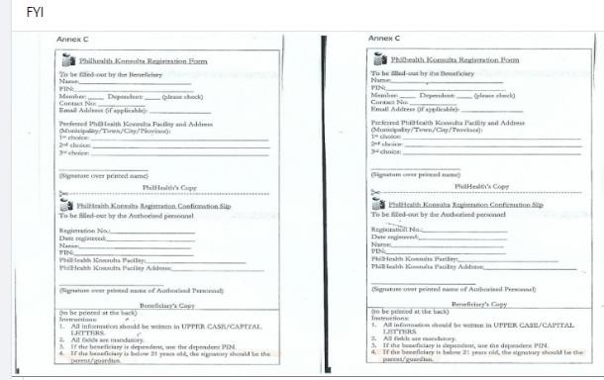Page **65** of **68**

|  |  |  |  |  |  |  |
| --- | --- | --- | --- | --- | --- | --- |
| 3. Received PhilHealth Application Form | May 5, 2022 |  | LSPU Students | Siniloan Campus | OSAS |  |
| 4. Assisted 2 Families of departed  LSPU  students to claimed their insurance | June 01, 2022 |  | Parents OSAS Director  Standard Insurance Staff | San Pablo | OSAS |  |

Page **66** of **68**

|  |  |  |  |  |  |  |
| --- | --- | --- | --- | --- | --- | --- |
|  |  |  |  |  |  |  |
| 5. Posted and disseminated relevant announceme nts and information pertaining to student services on OSAS official facebook account/ social media | April to June 2022 |  | LSPU Students | Siniloan | OSAS Facebook official account |  |

Page **67** of **68**

|  |  |  |  |  |  |  |
| --- | --- | --- | --- | --- | --- | --- |
| 6. Conducted survey thru online platform pertaining to OSAS Clientele satisfaction survey | January to June 2022 |  | LSPU Students | Siniloan | OSAS Facebook official account |  |

Page **68** of **68**